CAPE ATLANTIC INTERGROUP OFFICE
1418 New Rd. Suite 4 Phone: (609) 641-8855
Northfield, NJ 08225
Date and Starting:
The meeting began Wednesday October 9, 2024, at 7:36 PM

Open with Serenity Prayer:
A moment of silence calling to bring your Higher Power into you and followed by the Serenity Prayer led by Michelle S., Vice Chairperson led this prayer.

Roll Call (Recording Secretary):

OFFICERS  Positions | Names | Present
Chairperson | Dawn | No
Vice Chair | Michelle S. | Yes
Recording Secretary | Megan Mc | Yes
Corresponding Secretary | Amber M. | No
Treasurer | Tina R. | Yes
Literature Treasurer | Shirl R. | Yes
Trustee | Donna S. | Yes

COMMITTEE  Positions | Names | Present
Archives | OPEN | OPEN
Budget and Finance | Peg S. | Yes
CAYPAA | Caroline S. | No
Hospitality | Debbie U. | Yes
H and I | Barbara M. | No
Literature | Kate D. | No
Newsletter | OPEN | OPEN
Office Manager | Lori B | Yes
Phones | Jennifer H. | No
PI/CPC | Rob H. | No
Policy and Structure | Doug G. | Yes
Round Up | Mike C. | Yes
Technology | Andrew V./Riley K | Yes
Unity | Karen N. | Yes
Website | OPEN | OPEN
Workshops | Marcine R. | Yes

- Officer Reports: (Vice Chair) Thank you everyone for attending, when delivering reports please keep them brief. Please send your synopsis of your reports for next week’s Business Meeting to Meghan Mc. (meghan4246@hotmail.com). Please highlight anything that needs to be ironed out beforehand. Please follow procedure by raising hands, be respectful to the person who has the floor. For a complete list of positions please see https://capeatlanticaa.org/steering-panel-and-committee-members/ All are welcome to attend, the second Wednesday of every month the meeting starts at 7:30 PM.

Reports were given as follows:

Position/Name
Chairperson | Nothing to report. Thank you all who showed up to the Day of Sharing event.
Vice Chair | Nothing to report. Thank you for allowing me to be of service.
Recording Secretary | Nothing to report. I just wanted to say hi and thanks for letting me be of service.
Corresponding Secretary | I attended the Day of Sharing last weekend and had a wonderful time. The breakfast buffet was amazing and it was great to be together with service workers from other Districts and Areas.  I sent out 11 “thank you” letters for donations we received since we met last month.
Treasurer | 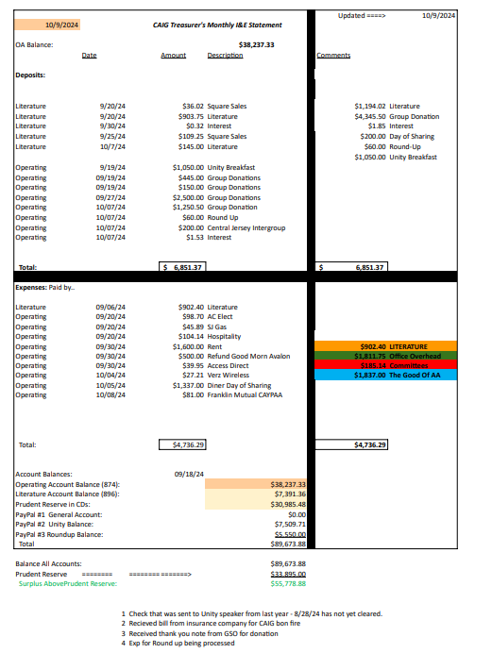
Literature Treasurer | The newly approved Literature Prices have been updated in Quick Books. Then the Inventory and tracking spreadsheets were updated and saved online. I also created new labels for the bookshelves and Kate and I are in the process of re-organizing the literature room. I am also helping out the unity committee doing tech-support for the ticket sales for the unity breakfast.
Trustee | Nothing to Report.

Committee Chair Reports:

Position/Name
Archives – OPEN POSITION | OPEN POSITION
Area 45 | Not represented
Budget and Finance | No report. Thank you for letting me serve.
CAYPAA | Business meeting held 10/2  Fall back into Unity event being held Sunday November 3rd at 12pm at R&J Farms. Has pumpkin picking and hayrides. Attendees pay themselves, can buy in bundles. Flyer to come.
Hospitality | Nothing to report. Thank you for allowing me to serve.
H and I | No report. Not in attendance.
Literature | No report. Not in attendance
Newsletter – OPEN POSITION (Donna is reporting) | Anyone who is interested please reach out to Donna S. or Dawn I.
Office Manager | Nothing to report. Thank you for allowing me to serve.
Phones | Hi Everyone, I’m an alcoholic and my name is Jenn. This month we received 171 calls and only 6 of those calls went into the voicemail. All of the voicemail calls were returned. We’ve had 5 new inquires from people wanting to join the hotline committee! All of our primary slots are currently full but we are always looking for people to join the committee to take a back up slot and/or to join the 12th step list. If you you have any questions or would like to join the committee please call or text me at: 609.224.4411 or email: PhoneChair@CapeAtlanticAA.org Service Opportunity I’ve observed that our hotline receives over 400 calls a month. Among these, approximately 3-5 per week are from individuals seeking rides to AA meetings. The majority of these calls are from people residing in recovery houses. Many individuals in recovery houses face barriers to attending AA meetings due to lack of transportation. This is a missed opportunity for us (AA members) to provide a service. The co-chair and myself propose a solution: 1. Compile a list of volunteers willing to provide transportation to AA meetings. 2. Distribute these lists to recovery houses within the Cape Atlantic Intergroup Area 3. Residents of these houses will be able to contact members for a ride to a meeting. We’re asking the IGRs to gather contact information from members in their groups who are willing to volunteer their time to provide a ride to those in need. Benefits of this service 1. Improved Access: Ensures that individuals in recovery houses have reliable transportation to AA meetings 2. Enhance Support: Provides a tangible way for members to give and support others in their recovery journey 3. Community Building: Strengthens the connection within our AA community and foster a spirit of mutual support
PI/CPC | Good evening All. I won’t be able to make the steering meeting tonight because I have another commitment tonight.  My PI/CPC report is as follows.  IDRC Commitments are filled for the year.  I have contacted Scott Plecker from Bridging the Gap requesting more brochures to be given out at next weeks Intergroup meeting so they can be distributed by our AA’s at the H & I commitments in November.
Policy and Structure | No report.  Thank you for allowing me to serve.
Round Up | Held the monthly RoundUp meeting Thursday October 3rd. Happy to report we are in the home stretch. We are finalizing all printed materials in the next coming weeks so we can get together the first week of November for the stuffing party. Badges and lanyards will be assembled so if you're not registered by October 24th, you will have to write your own information on your badge. If you are registered by October 24th, your badge will look like this. (show example) All meal tickets must be purchased by this date as well! We must notify the hotel the amount of attendees for food preparations by November 1st plus we will be having a stuffing party November 3rd. This will help us determine what meal tickets go in each individual envelope. Then when you check in at the registration desk at the Waves Roundup, you will be handed your envelope with everything you need to navigate The Fellowship You Crave!  All tables have been confirmed and will be scattered throughout the conference floor. Please visit any of our friends at the Accessabilities table, Corrections table, Grapevines table, Al-Anon table,  Speakers tapes and CDs table, Merchandise table, Literature table, and of course our Baskets and Raffel tables. Roy from Archives will also be there, but since we love this program so much, he gets an entire room, so be sure to check that out as well.  We are really excited for everyone to meet and hear all of the speakers and the workshops are going to be awesome as well.  Please get those hotel rooms booked as well! No one wants to drive home late after the partys we have planned for both Friday and Saturday night. You'll be sober, but you'll be exhausted that's for sure. I expect lots of laughing and even more dancing so GAS UP!
Technology | · Work on internet issues  o Look over current plan  o Compare to other plans and check out our router  o Find suitable replacement plans  o Possibly replace current router  · Finish installation of TV/ all-in-one device  o Hide wires  o Install connection box  o Finalize room layout  o Figure out how to run two cameras simultaneously with zoom without having to screen share.
Unity | The itinerary is completed for the Unity Breakfast this Sunday. Tickets are sold out, 265 total! Dawn or Michelle will speak about the history and interworking’s of intergroup and Mike C. will speak about the Roundup. Thank you for letting me serve.
Website – Open Position | POSITION IS OPEN
Workshops | The flyer is out for the upcoming workshop “Humility and Higher Power” on October 26th. Thank you for letting me serve.

Questions/Comments concerning Reports – Q: How much do the meals at the roundup cost? A: Information can be found on the Roundup website:
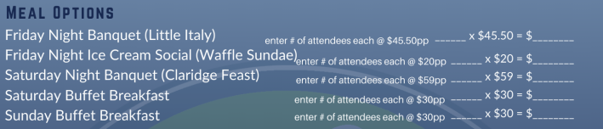

OLD BUSINESS –
N/A

NEW BUSINESS –

1) Riley K appointed as Technology Co-Chair

The Next Business Meeting is Wednesday, October 16th at 7:30 PM at 1418 New Road, Northfield, NJ
Business Meetings are not limited to Officers or Committee Members – ALL are welcome to attend!
For those who are unable to attend in person, CAIG Business Meetings are hybrid.
Hybrid Meeting ZOOM ID: 164 233 922

Steering Committee Meeting:
Wednesday, November 13th at 7:30 PM – 1418 New Road, Northfield, NJ

Hybrid Meeting ID 542 744 809

Motion to Close – Motion to close came from Doug G. at 8:00 PM, followed by a second, Lori B. Michelle S. lead the close with the Responsibility Pledge.

