CAPE ATLANTIC INTERGROUP OFFICE
1418 New Rd. Suite 4 Phone: (609) 641-8855
Northfield, NJ 08225
Date and Starting:
The meeting began Wednesday, October 16th, 2024 at 7:31 PM
Open with Serenity Prayer:
A moment of silence calling to bring your Higher Power into you and followed by the Serenity Prayer led by Dawn I., Chairperson led this prayer.
Roll Call (Recording Secretary):
OFFICERS  Positions | Names | Present
Chairperson | Dawn I. | Yes
Vice Chair | Michelle S. | Yes
Recording Secretary | Meghan Mc | Yes
Corresponding Secretary | Amber M. | Yes
Acting Treasurer | Tina R. | Yes
Literature Treasurer | Shirl R. | Yes
Trustee | Donna S. | No

COMMITTEE  Positions | Names | Present
Archives | OPEN
Budget and Finance | Peg S. | Yes
CAYPAA | Caroline S. | No
Hospitality | Deb U. | Yes
H and I | Barb M. | No
Literature | Kate D. | Yes
Newsletter | OPEN
Office Manager | Lucia/Lori | Yes
Phones | Jen H.. | No
PI/CPC | Rob H. | Yes
Policy and Structure | Doug G. | Yes
Round Up | Mike C. | Yes
Technology | Doug W. | Yes
Unity | Karen N. | Yes
Website | OPEN
Workshops | Marcine R. | No
Quorum:
Intergroup Representatives | Headcount  (In Person/Online)
Regular In Person  Regular Online | 17  7
Alternates in Person  Alternates Online | 0  1
Total | 25
Area 45 Report: Joe E. Area 45 Alternate Delegate Report
Good evening Cape Atlantic Intergroup! My name is Joe and I am an alcoholic. I have the honor and privilege to serve as the Area 45 Alternate Delegate and liaison between South NJ’s 3 Intergroups and General Service. A duty I will do with great earnest and a compassionate heart. We have an exciting couple of months ahead of us and I am going to provide both dates to watch and potential updates to come down the pike.
- Area 45 Fall Assembly Assembly
- Sunday November 17th: Registration starts at 8:30, Assembly starts at 10 am
- Location: Gibson House 535 E Main St, Evesham, NJ
- Summer Assembly-Notable Motion that was voted down-District 42 is now no longer in existence. However, a new motion was proposed for the Fall Assembly.
- Area Inventory Saturday October 19th at Elmer Grange 535 Daretown Rd, Elmer, NJ from 9a to 12p
- Day of Sharing (Hosted by Cape Atlantic Intergroup) has a date of Saturday October 5th in the meeting room at the Northfield Diner
- Anyone interested in being a committee member for Virtual NERAASA 2025, please reach out me and I will get you the invite to our monthly committee meeting
Above all, I am really looking forward to working with everyone and becoming a part of the Cape Atlantic Intergroup Family. If you have any questions or comments, always feel free to call, text, or email. My contact information is below:
E-Mail-Altdelegate@snjaa.org Phone-609-705-1284
New Representatives: Adam M., Getting Sober Young-Somers Point; Jessica M, Keep it Real- Ventnor

New Alternates Representatives: N/A
Anniversaries:
Teri H. 8 years; Carolyn M- 6 years; Lori- 4 years; Doug W. 1 year; Justin B- 11 years; Kat- 7 years
Announcements: Reminder **Roundup Registration Needed!!!***
Opening Prayer: 10th Step Prayer led by Danny S.
Tradition Reading: Tradition Ten led by Judy B.C.
Chairperson Opening Remarks: Thank you to everyone in attendance whether you are in person or virtually, your participation is vital to the success of Cape Atlantic Intergroup. If you are an Intergroup Representative, please be sure to sign in, the sign in sheet is at the door right next to the agenda, which everyone should have picked up on their way in. Please make sure that you write clearly and accurately to ensure that you receive the minutes in a timely manner and guarantee certainty during elections, and we will be doing some voting tonight. We will hold all questions and comments until the end of the Reports are completed. Please do not talk over one another, please try to keep your conversation in the gally to a minimum.
Presentation of last month’s Business Meeting Minutes (Recording Secretary): Did everyone receive last month’s Business Meeting Minutes; may I have a motion to approve the Minutes as presented? Motion to approve was made from the floor, a vote was taken, and Minutes from September were unanimously approved.
Officer Reports:

Position/Name
Chairperson –  Dawn I. | Nothing to report
Vice Chair -  Michelle | Nothing to report
Recording Secretary – Meghan Mc | Nothing to report
Corresponding Secretary – Amber M. | Good evening,  I attended the Day of Sharing October 5th and had a wonderful time. The breakfast buffet was amazing and it was great to be together with service workers from other Districts and Areas.  I also attended the Unity Breakfast on Sunday and it was a lovely experience, as always. Thank you, Karen N. and everyone on the Unity Committee!  I sent out 11 “thank you” letters for donations we received since we met last month.
Treasurer – Tina R. | 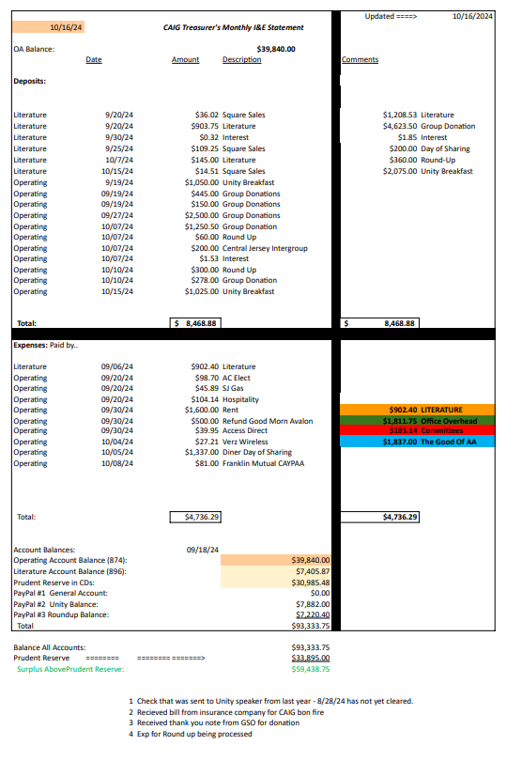
Literature Treasurer – Shirl R. | The newly approved Literature Prices have been updated in Quick Books. Then the Inventory and tracking spreadsheets were updated and saved online. I also created new labels for the bookshelves and Kate and I are in the process of re-organizing the literature room. I also helped out at the unity committee doing tech-support for the ticket sales for the unity breakfast
Trustee – Donna S. | No Report.

Committee Chair Reports:
Position/Name
Archives – OPEN POSITION | OPEN POSITION
Budget and Finance – Peg S. | No report. Thank you for letting me serve.
CAYPAA – Caroline S. | Business meeting held 10/2  Committee discussed doing a unity event on Nov. 3rd which we were going to announce at meetings, due to unforeseen circumstances we will be rescheduling that for a later date. Updates to come.  Our roller skating event in December is approaching! Date confirmation and flyer to come.
Hospitality – Deb U. | Nothing to report.
H and I – Barbara M. | Just a reminder to always keep your commitments and if you cannot reach out to your Home group Intergroup or somebody else to help cover what you can attend.
Literature – Kate D. | What Shirl said. Thank you for allowing me to serve.
Newsletter – OPEN POSITION | (Donna is reporting) Anyone who is interested please reach out to Donna S. or Dawn I.
Office Manager–Lori B. | Nothing to report. Thank you for allowing me to serve.
Phones – Jen H. | Hi Everyone, I’m an alcoholic and my name is Jenn. This month we received 171 calls and only 6 of those calls went into the voicemail. All of the voicemail calls were returned. We’ve had 5 new inquires from people wanting to join the hotline committee! All of our primary slots are currently full but we are always looking for people to join the committee to take a back up slot and/or to join the 12th step list. If you have any questions or would like to join the committee please call or text me at: 609.224.4411 or email: PhoneChair@CapeAtlanticAA.org Service Opportunity I’ve observed that our hotline receives over 400 calls a month. Among these, approximately 3-5 per week are from individuals seeking rides to AA meetings. The majority of these calls are from people residing in recovery houses. Many individuals in recovery houses face barriers to attending AA meetings due to lack of transportation. This is a missed opportunity for us (AA members) to provide a service. The co-chair and myself propose a solution: 1. Compile a list of volunteers willing to provide transportation to AA meetings. 2. Distribute these lists to recovery houses within the Cape Atlantic Intergroup Area 3. Residents of these houses will be able to contact members for a ride to a meeting. We’re asking the IGRs to gather contact information from members in their groups who are willing to volunteer their time to provide a ride to those in need. Benefits of this service 1. Improved Access: Ensures that individuals in recovery houses have reliable transportation to AA meetings 2. Enhance Support: Provides a tangible way for members to give and support others in their recovery journey 3. Community Building: Strengthens the connection within our AA community and foster a spirit of mutual support
PI/CPC – Rob H. | IDRC Commitments are filled for the year.  I have contacted Scott Plecker from Bridging the Gap requesting more brochures to be given so they can be distributed by our AA’s at the H & I commitments in November.
Policy and Structure – Doug G. | No report.  Thank you for allowing me to serve.
Round Up – Mike C. | Held the monthly RoundUp meeting Thursday October 3rd. Happy to report we are in the home stretch. We are finalizing all printed materials in the next coming weeks so we can get together the first week of November for the stuffing party. Badges and lanyards will be assembled so if you're not registered by October 24th, you will have to write your own information on your badge. If you are registered by October 24th, your badge will look like this. (show example) All meal tickets must be purchased by this date as well! We must notify the hotel the amount of attendees for food preparations by November 1st plus we will be having a stuffing party November 3rd. This will help us determine what meal tickets go in each individual envelope. Then when you check in at the registration desk at the Waves Roundup, you will be handed your envelope with everything you need to navigate The Fellowship You Crave!  All tables have been confirmed and will be scattered throughout the conference floor. Please visit any of our friends at the Accessabilities table, Corrections table, Grapevines table, Al-Anon table,  Speakers tapes and CDs table, Merchandise table, Literature table, and of course our Baskets and Raffel tables. Roy from Archives will also be there, but since we love this program so much, he gets an entire room, so be sure to check that out as well.  We are really excited for everyone to meet and hear all of the speakers and the workshops are going to be awesome as well.  Please get those hotel rooms booked as well! No one wants to drive home late after the partys we have planned for both Friday and Saturday night. You'll be sober, but you'll be exhausted that's for sure. I expect lots of laughing and even more dancing so GAS UP!
Technology – Doug W. | Held day of sharing event  - Moved all in one device over to location along with projector for mobile zoom  - Was not able to make event and had Natt cover position  Added to Verizon wifi account to be able to start making changes and upgrading the current wifi network  New Business (Next steps on projects)  - Create new budget for next steps on install with all-in-one device.  - Determine options for wifi and create budget on different costs
Unity – Karen N. | We had a successful Unity Breakfast! Shirl and Barbara worked the door and had no problems with and using the new system. Donna, Willy and I greeted and seated. The only complaint was it was taking so long to be called up to the buffet and a glitch with running out of bacon, but they made a fresh batch. Now we move on the NYE!  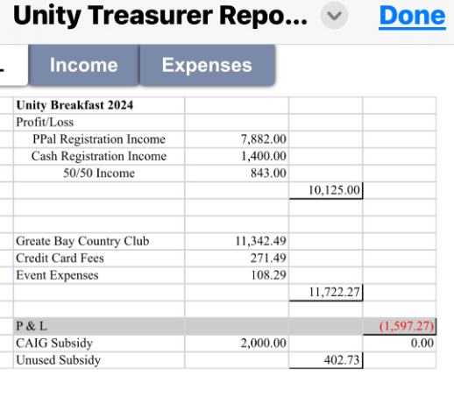
Website – Open Position | POSITION IS OPEN
Workshops – Marcine R. | The flyer is out for the upcoming workshop “Humility and Higher Power” on October 26th. Thank you for letting me serve.

Questions/Comments concerning Reports:
Dawn Tina: We are waiting for 2 checks to clear, SJ and Area.
Dawn Shirl: Request copies of new lit price list
Dawn Karen/Mike: Unity Breakfast successful, request for a table at Roundup for CAIG open positions.
Kat Rob: FYI RCA has a lot of BTG brochures already at facility.
Jess M Mike C: When are the Roundup Raffle Baskets due? – You can bring with you to the roundup, bring to CAIG office, meet up in community, etc. Aubrey to assist with basket collections.
Carolyn Tina: Confirm report, $8,400 in and $4,736 out for October? – Yes
Pat Group: Dawn, can you explain what NERAASA is? -- The purpose of the Northeast Regional Alcoholics Anonymous Service Assembly (NERAASA) is for GSRs, DCMs, Area Committee Members and Intergroup and Central Office Representatives of the Northeast Region to discuss General Service Conference related issues and concerns affecting AA as a whole, as well as pertinent aspects of recovery, unity and service common to the Areas of the Northeast Region.

REGISTRATION IS OPEN FOR NERAASA 2025 (FEBRUARY 21 - 23, 2025) WHICH WILL BE VIRTUAL. YOU CAN GET MORE INFORMATION ABOUT 2025 AT:
https://area45snjaa.org/neraasa-2025/
or
REGISTER TODAY
https://area45snjaa.org/neraasa-2025-registration/

Mike C. Panel: Is there a stand for the roundup drop banner? – Shirl was thinking about purchasing PVC pipe and making one, solidify details with her.

OLD BUSINESS –

N/A

NEW BUSINESS –

  - Dawn had call with Parker at Brigantine Golf Links to discuss possible advertising on score card. Ad will not promote AA, it will simply state something like, “Drinking Problem?” and have contact info to reach AA hotline. Possible QR code and phone #. Please bring back to groups for feedback, we will bring up at next month’s steering meeting for vote.
  - Dawn is heading the CAIG workshop at Waves Roundup on Saturday and will host a skit, “Troublemakers and Traditions.” Cast of 7 needed, see Dawn if interested in participating.
  - Dawn suggesting idea for upcoming outings. Idea to hold Golf outings that are held by all counties in the CAIG area. More discussions needed.

H&I Commitments – Pending Report

UPCOMING CAIG MEETINGS:
CAIG Steering Business Intergroup Meeting: Wednesday, November 13th, 2024 CAPE ATLANTIC INTERGROUP OFFICE
1418 New Rd. Suite 4
Northfield, NJ 08225

All are welcome to attend this is not limited to officers or committee positions.
Those who cannot attend in person here is the zoom information.
Meeting ID 542 744 809

______________________________________________________________________________

CAIG Business Intergroup Meeting: Wednesday, November 20th, 2024 CAPE ATLANTIC INTERGROUP OFFICE
1418 New Rd. Suite 4
Northfield, NJ 08225

All are welcome to attend this is not limited to officers or committee positions.
Those who cannot attend in person here is the zoom information.
Meeting ID: 832 9623 3517

Motion to Close – Motion to close came from the floor at 8:48 PM, followed by a second. Dawn I. lead the close with the Responsibility Pledge.

